Program Structures and Algorithms

Spring 2024

NAME: Gautham Venkata Krishna Prasad

NUID: 002249901

GITHUB LINK: https://github.com/gauthamkris7neu/INFO6205Assignment

**Task:**

Solve 3-SUM using the Quadrithmic, Quadratic, and (bonus point) quadraticWithCalipers.

**Relationship Conclusion (Brief Explanation of Why the Quadratic Method(s) Work) :**

The quadratic methods work effectively for this problem because they leverage the sorted nature of the array to reduce the problem space. Rather that checking all possible triplets, we focus only on viable candidates so it reduces the number of operations required drastically. The two pointer and calipers techniques make sure that each element is involved in the sum calculation only a linear number of times.

This method works mainly because we transform the problem into a series of steps where each step can be solved in linear time and the total number of steps is also linear, resulting in quadratic performance which is significantly better than cubic for large datasets.

**Evidence to support that conclusion (Spreadsheet Showing Timing Observations) :**

With the help of the main method and stopwatch class recorded the timings..

Source Class was used to generate the array with random values..

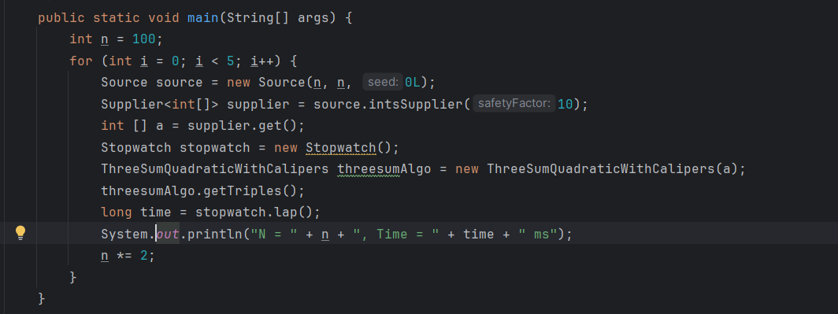

|  |  |  |  |  |
| --- | --- | --- | --- | --- |
| N(Number of Elements in the array) | Quadrithmic | Quadratic | Cubic | Quadratic with Calipers |
| 100 | 1ms | 1ms | 2ms | 2ms |
| 200 | 0ms | 0ms | 2ms | 0ms |
| 400 | 1ms | 0ms | 2ms | 1ms |
| 800 | 5ms | 1ms | 14ms | 2ms |
| 1600 | 24ms | 2ms | 418ms | 2ms |

**Unit Test Screenshots:**

